Name ___________________________________ SOL 8.11
Area and Perimeter of Composite Figures Quiz

Find the area of each of the following polygons.

1)
15 inches
Area: __________________

8 inches 10 inches

6 inches

2) 21 cm

Area: ___________________
15 cm

30 cm

3) What is the area of the parallelogram?

Area: ______________
4 feet 7 feet

9 feet

4) Cindy wants to put a ribbon around her table. What is the minimum amount of ribbon that Cindy will need to put it around her table?
2 in
3 in, 3 in

3 in 3 in

2 in
5) Bob wants to cover his yard with mulch. What is the minimum amount of mulch that he will need to cover his yard?
50 feet

41 feet
29 feet
38 feet

6) Pablo has a large, circular rug on his square-shaped bedroom floor.
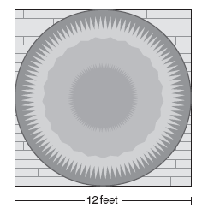

If the diameter of the rug is equal to the length of the bedroom floor, what is the area of the rug?

7) George wants to put new carpet in this family room. What area will the new carpet cover?

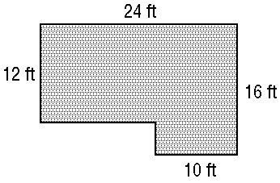

8) George needs to put wood trim along the perimeter of the room. How much trim does George need to buy?

Use this figure of Samantha’s backyard to answer the following questions.

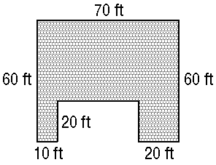

9) Samantha is buying fertilizer for the grass in her backyard. How many square feet does she have to fertilize?

10) If Samantha puts a fence around the perimeter of her yard, how many feet of fencing does.

