Probability Stations

Students will review probability by completing activities at 3 stations. Students may move to stations or the station activities can be passed from one group to the next.

Activity 1: Independent or Dependent

Students will sort cards into 2 groups – independent or dependent events. Then, students will determine the probability of each event.

Activity 2: Probability Practice

Students will determine the probability of independent and dependent events with and without replacement.

Activity 3: Self-Paced Flip Chart

Self-paced Flip chart to review all probability

****Important Note*****
Leave time at the end of class to go over answers to the probability problems and clear up any confusion/misconceptions before the test.

Probability Stations
Activity 1: Independent or Dependent

Sort the cards into 2 groups – independent or dependent events. Then, determine the probability of each event.

Cards on next page.

1  What is the probability that a coin will land on heads and then a coin will land on tails? | 2  You have a bag of 17 marbles. Four are blue, 6 are green, 2 are red, and the others are yellow. What is the probability of drawing a red marble, putting it aside, and then drawing a green marble?
3  You have a bag of 17 marbles. Four are blue, 6 are green, 2 are red, and the others are yellow. What is the probability of drawing a green marble, putting it aside, and then drawing another green marble? | 4  You have tiles numbered 1 – 9 in a bag. What is the probability of drawing the number 2, putting it aside, and then drawing the number 5?
5  You have a bag of 17 marbles. Four are blue, 6 are green, 2 are red, and the others are yellow. What is the probability of drawing a blue marble, replacing it, and then drawing a yellow marble? | 6  What is the probability of drawing the ACE of diamonds from a deck of cards, putting it back in deck, shuffling the deck, and then drawing the ACE of clubs?
7  What is the probability of rolling a 3 on a 6-sided number cube and then NOT rolling a 3 on a 6-sided number cube? | 8  What is the probability of drawing a Jack from a deck of cards, putting it aside, and then drawing another Jack?

Activity 2: Probability Practice

Students will determine the probability of independent and dependent events with and without replacement.

Students will determine the probability of each of the following.

Cards on the next page.

1.  Kerry has a game that uses 20 tiles that are the same shape and size.  - 20% of the tiles are rectangles.  - 40% of the tiles are trapezoids.  - The remainder of the tiles are hexagons.  Kerry chooses one hexagonal tile from the bag and then gives the bag to her friend Pam. If Pam takes one tile from the bag without looking, what is the probability that the tile she chooses will be a quadrilateral? | 2.  Donna has a bag of candy.  - of the candy is caramel.  - of the candy is chewy.  - The remainder of the candy is chocolate.  What is the probability that Donna will choose a piece of candy that is chewy, and then choose a piece of candy that is chocolate?  Plot your answer on the number line and label it.
3.  A spinner is divided into 8 equal sections as shown.  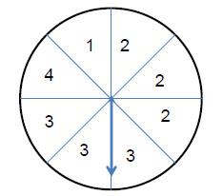  What is the probability that the spinner will land on a section that is NOT an even number and then land on a section that is an even number? | 4.  A spinner is divided into 8 equal sections as shown.  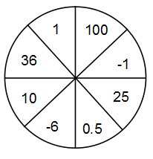  What is the probability that the spinner will land on a section that is an integer and then land on a section that is a perfect square?
5.  In the game that Tony is playing, there is a 30% chance the spinner will land on red and a 25% chance that the spinner will land on yellow.  What is the probability that Tony will NOT spin red, then will spin yellow and then will spin red? | 6.  When using a 6-sided number cube, what is the probability or rolling a 3, then not rolling a 3, and then rolling an even number?

Probability Review Stations Answer Sheet Name __________________________

Activity 1: Independent or Dependent

Card Number | Independent of Dependent? | Probability  (as a fraction, a decimal, and a percent)
1
2
3
4
5
6
7
8

Activity 2: Probability Practice

Question  Number | Work | Answer
1
2 |  | 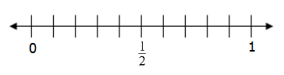
3
4
5
6

Activity 3: Self-Paced Flip Chart

Question  Number | Work | Answer
1
2
3
4
5
6
7
8

