Making Scatter Plots!

Click on the following link: http://nces.ed.gov/nceskids/createagraph/default.aspx

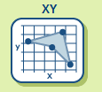
Click on the “XY” graph type.

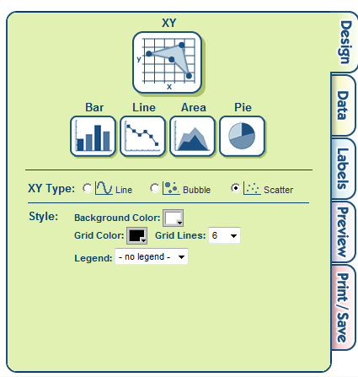
Under the “Design” tab:
- choose “scatter”
- change the number of grid lines to 6
- Under the drop down tab for legend, choose “no legend”
- Personalize: you can change the background color & grid color, BUT MAKE SURE THAT THEY ARE COLORS YOU WILL BE ABLE TO READ TOGETHER.

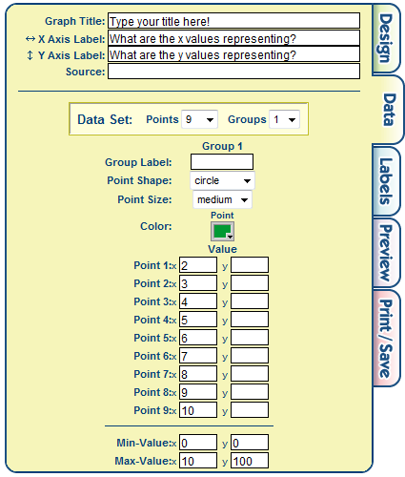
Under the “Data” tab:
- Type in a title that will represent what the data on the graph will be showing you.
- Type in a label for your x-axis, you may want to refer back to your packet.
- Type in a label for your y-axis, you may want to refer back to your packet.
- Type your first and last name in source.
- Under “Data Set” and the “Points” drop down menu, choose as many points as you have.
- Under “Value” and your points, enter your data from the T-chart in your packet.
- Next to “Min-Value” type in 0 and 0
- Next to “Max-Value” type in your highest values for both x and y coordinates.
- Personalize: You can change the point shape, size and color, but make sure that your point doesn’t blend into your background color.
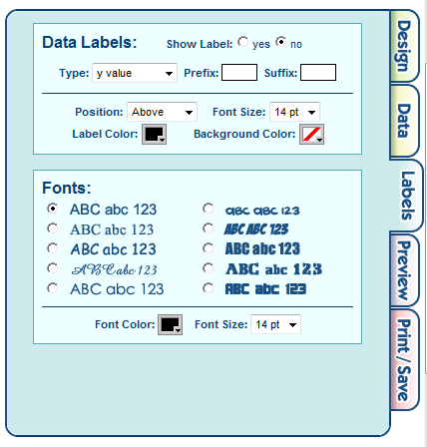
Under the “Labels” tab:
- Under “Data Labels” and show labels, choose “no”
- Personalize: Choose which font style, color, size you would like for your graph.

Under the “Preview” tab:
- Take a look at your final graph and make sure that your title and labels are in the correct positions. If you need to change any of these settings click on the Data tab.
- Make sure that any personalized “touches” that you made, i.e. color, font, size etc. doesn’t prevent your data from being displayed. Design, Data and Labels tabs all have personalized items that you can fix if need be.
- Make sure that your scales for both x and y axis demonstrates your data well. This can be fixed under the Data tab.

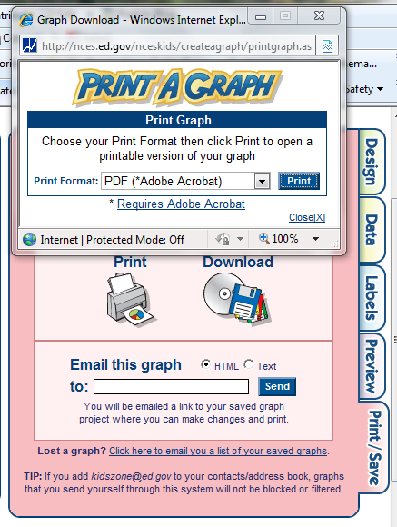
Under the “Print/Save” tab:
- Click on Print.
- In the new window choose PDF format, click on the print button.

- Your graph will open up in a new window, from there click on the save icon and save it to your “I Made These Math” folder as “YourLastNameScatterPlot”
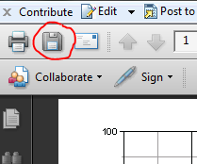

- Once you have saved your graph to your computer, drop it into the dropbox in School Space. In the dropbox and once you have selected your graph, make sure to click “upload file” then “finish”. After you have attached your graph click “Submit”

