Name _____________________________ Relations and Functions Homework (Day 2)

1. **Continuous or Discrete** - Determine if the graphs of the following functions are continuous or discrete. Graph the function and explain why the graph is continuous or discrete. Then identify the independent and dependent variables.

A) A rain gauge collected 1 inch B) Each slice of pizza costs $1

of rain each hour for 4 hours.

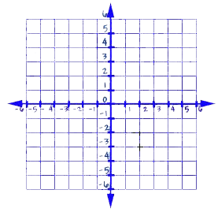

IV: ____________ DV: ____________ IV: ___________ DV: ___________

Continuous or Discrete? _________ Continuous or Discrete? __________

Explain: Explain:

1. **Relations and Functions**
2. Use the relation below to answer the following questions.
3. Identify the domain ______________

and range _______________________

1. Does the list of ordered pairs represent

a function? __________ Why or why not?

__________________________________

__________________________________

