Functions Sort
Directions: Sort the following into 2 columns, Function and Not a Function

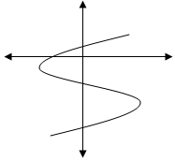 | 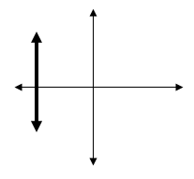
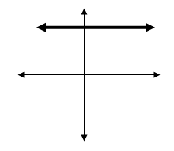 | X Y  -5 -1  0 8  3 9  17 0
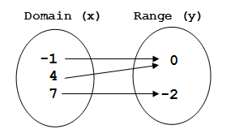 | 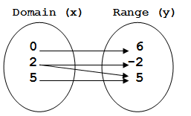
X 3 4 5 6  Y 0 0 0 0 | 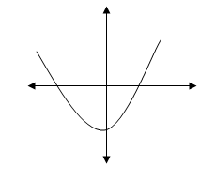
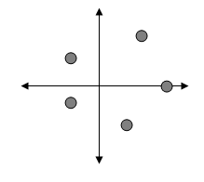 | {(0, 2), (1, 5), (1, 4), (3, 8), (21, 9)}
{(-1, -1), (-2, -2), (-3, -3), (-4, -4)} | X Y  -2 -1  -2 5  0 7  12 2
{(4, 0), (5, -3), (6, -6), (7, -9)} | {(-12, 10), (-3, -7), (-3, 7), (0, 4), (3, 15)}

