Functions Notes
Review

A relation is a set of __________________ ___________________.

A function is a _____________ _______________ in which each element of the ______________ (____ values) is paired with exactly one element of the _____________ (_______ values).

- Is it a function?
  - There are two easy ways to determine if a relation is a function.
    - In a table or set of ordered pairs, check to see if each ___________ has only ____________ ______________.
2) Use the ______________ _________________ ________________.

- Vertical Line Test
  - What is it?
It is an easy way to determine if a ________________ represents the graph of a ______________________.
  - How do you use it?
    - Use a pencil, ruler, or another straightedge to represent a _______________ _________________.
    - Place the straightedge to the ________________ of the graph. Move the straightedge from left to right, ___________ the graph.
    - If the straightedge touches ___________ ____________ than __________ point ______ ______ __________ on the graph, then the graph represents a ________________.
  - Why does it work?
If a vertical line touches only ________ point at a time, then each ______ coordinate will be paired with only 1 __________ coordinate.
  - Example
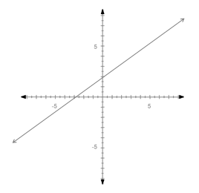
Does the graph represent a function? Explain.
  - Example 2
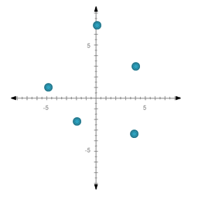
Does the graph represent a function? Explain.

- Graphs of Functions
  - The graph of a function can be ________________ or ________________.

- Continuous Functions
  - In the graph of a continuous function, the points are _____________ with a continuous _________________.
  - This is because _______________ point on the line has ______________ based on the original problem.
  - Example: A scientist measured the temperature of a liquid each hour from 10:00am to 2:00pm. At 10:00am, the temperature was 2⁰. She found that the temperature was rising by 2⁰ each hour.
  - Create a table and a graph to represent this situation.
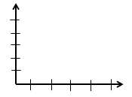

  - Determine the independent and dependent variables.
Independent: ___________________________ Dependent: _____________________

- Discrete Functions
  - In the graph of a discrete function, there are ______________, distinct points.
  - These points are __________________connected by a _________________ because only the points have meaning.
  - The points between the plotted points _________________ be interpreted based on the original situation.
  - Example: Tickets for the movies cost $10 each. Determine the cost for 1, 2, 3, 4 or 5 people to go to the movies.
  - Create a table and a graph to represent this situation.

  - Determine the independent and dependent variables.
Independent: ___________________________ Dependent: _____________________

