Name _____________________________ Date ___________________ Block _____________

Functions Homework (Day 3)

I. What are the domain and range of the relations represented in the tables below:

x | 1 | 0 | 1 | 6 | 12
y | -4 | -3 | 7 | 12 | 22
x | 5 | 6 | 7 | 8 | 9
y | 13 | 16 | 19 | 22 | 25

domain = {________________} domain = {________________}
range = {__________________} range = {__________________}

Does the table above represent a function? ____ Does the table above represent a function? ____
Why or why not? __________________________ Why or why not? __________________________

II. Find four solutions of each equation, and write the equations as ordered pairs.
1. x + y = -2 2. y = -2x + 2 3. y = x/3

III: Graph each equation by plotting ordered pairs.
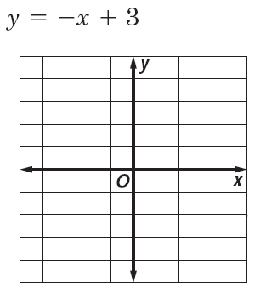
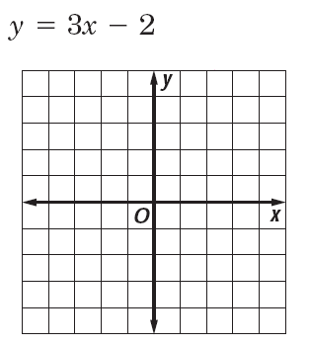
1. 2.

IV: Identify the independent and dependent variables.

- total calories, number of slices of bread
DV = ____________________ IV = ___________________

- cost of pencils, number of pencils
DV = ____________________ IV = ___________________

