Linear Functions

Dom

SOL 8.14.8.16, and 8.17

REVIEW:

What is a **function**?

* Remember: A **function** is a rule that has a unique output value for each input value.
* This means that there is **only one** _____ value for each _____ value.

What are **domain and range**?

* Remember: The **domain** is the set of _________ coordinates.
* Remember: The **range** is the set of _________ coordinates.

*A _________________ _________________ is a type of ______________ ______________.

* The graph of a linear equation is a ____________________ _______________.

*A linear equation represents a situation with a _______________ __________.

* To graph a linear equation:

1) create a _________

2) plot the _____________ _____________

3) connect the points to form a ______________ _______________.

**I. Graph each linear function. Then, identify the domain and range of the ordered pairs.**

**1) Function Rule: Table: Graph:**

|  |  |  |
| --- | --- | --- |
| **Input x** |  | **Output**  **y** |
|  |  |  |
|  |  |  |
|  |  |  |
|  |  |  |
|  |  |  |

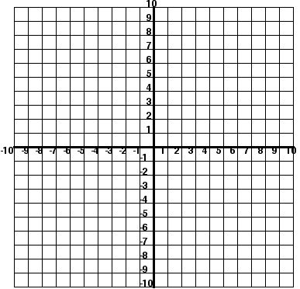

**y = x -3**

**Domain: __________________________ Range __________________________**

**2) Function Rule: Table: Graph:**



|  |  |  |
| --- | --- | --- |
| **Input x** |  | **Output**  **y** |
|  |  |  |
|  |  |  |
|  |  |  |
|  |  |  |
|  |  |  |

**y = -3x**

**Domain: __________________________ Range __________________________**

**3) Function Rule: Table: Graph:**



**y = -3x + 2**

|  |  |  |
| --- | --- | --- |
| **Input x** |  | **Output**  **y** |
|  |  |  |
|  |  |  |
|  |  |  |
|  |  |  |
|  |  |  |

**Domain: __________________________ Range __________________________**

**II: Find four solutions of each equation, and write the solutions as ordered pairs.**

1. x – y = 3 2. y = 5x -6 3. 