**Course 3 Quiz Review Name _____________________**

**Functions and Relations**

**Part I: The Coordinate Plane. Identify and label the points on the coordinate plane below:**

1) Plot A (3, -3)

Location: ________

2) Plot B (0, -2)

Location: ________

3) Plot C (5, 0)

Location: ________

4) Identify point K: __________

5) Identify point L: ___________

6) Identify point M: __________



**Part II: To Be or Not to Be … A Function**

**Do the following relationships represent functions? Explain your answer.**

|  |  |
| --- | --- |
| ***x*** | ***y*** |
| 2 | 5 |
| 4 | 7 |
| 8 | 5 |
| 2 | 2 |

7. 8.

|  |  |
| --- | --- |
| ***x*** | ***y*** |
| 3 | 6 |
| 5 | 10 |
| 6 | 6 |
| 9 | –2 |

9.  10. 

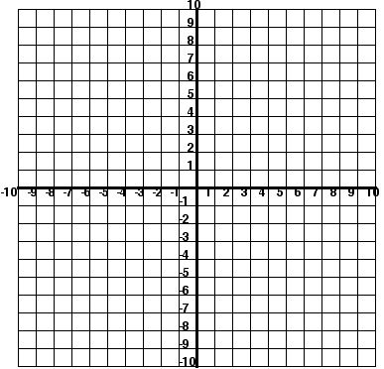11. 12.

2 -2 2

4 -4

6 7

8 -8

**# 13 – 14 Given the following linear function, complete the table of values and graph on the coordinate plane provided. Then, identify the domain and range of the table of values.**

13. **Function Rule: Table: Graph:**

|  |  |
| --- | --- |
| **Input x** | **Output**  **y** |
| **-2** |  |
| **-1** |  |
| **0** |  |
| **2** |  |
| **3** |  |



**y = 2x + 1**

Domain: __________

Range: ___________

14. **Function Rule: Table: Graph:**

|  |  |
| --- | --- |
| **Input x** | **Output**  **y** |
| **-6** |  |
| **-3** |  |
| **0** |  |
| **3** |  |
| **6** |  |



**y = x - 2**

**3**

Domain: __________

Range: ___________

15. Identify the range of the function **y = x2 + 1** for the domain {-4, 5, 8}.

# 16 – 17 Complete the table for each equation.

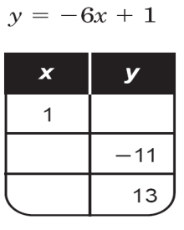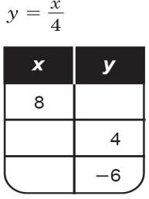

16. 17.

j0299079

Remember to solve for x by using

inverse operations……..

Make sure that you know the vocabulary!!!!!!