Name _____________________________________ Date _______________ Block __________

Course 3: Functions and Graphs

Fill in the tables to correspond to the given function rule.

**1. y = 4x – 8 2. y = -2x + 3 3. y = -5x – 2**

|  |  |
| --- | --- |
| **Input** | **Output** |
| **-1** |  |
| **0** |  |
| **1** |  |
| **2** |  |
| **3** |  |

|  |  |
| --- | --- |
| **Input** | **Output** |
| **4** |  |
|  | **5** |
| **8** |  |
|  | **8** |
| **-3** |  |

|  |  |
| --- | --- |
| **Input** | **Output** |
| **5** |  |
| **6** |  |
|  | **0** |
|  | **-3** |
|  | **2** |

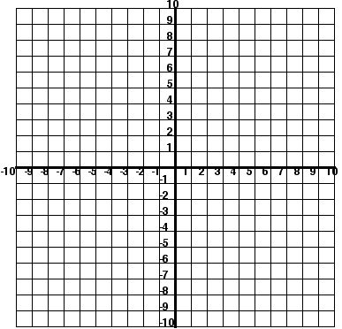**4. Graph the rule used in number one using the points in the table for #1.**

**5.**

|  |  |  |  |  |  |  |
| --- | --- | --- | --- | --- | --- | --- |
| **n** | **-3** | **-2** | **-1** | **0** | **1** | **2** |
| **3n** |  | **?** |  | **1** | **3** | **9** |

**What would fill the “?” in the table to the left?**

**A 1/81 B 1/9 C -1 D -9**

**Identify the independent and dependent variables.**

**6. number of donuts, cost of donuts**

**DV = __________________________ IV = ______________________**

**7. cost of carpet, amount of space to carpet**

**DV = __________________________ IV = ______________________**

8. Find three solutions for the function rule: x – 2y = 4. Write the solutions as ordered pairs.

9. Find three solutions for the function rule: y = 6x + 9. Write the solutions as ordered pairs.

Find the function rule for each of the following tables:

10. 11.

|  |  |
| --- | --- |
| X | Y |
| 10 | -20 |
| 6 | -12 |
| -6 | 12 |
| 4 | -8 |

|  |  |
| --- | --- |
| X | Y |
| 7 | 5 |
| 6 | 4 |
| 5 | 3 |
| 4 | 2 |

12. 13.

|  |  |
| --- | --- |
| X | Y |
| 1 | 8 |
| 4 | 11 |
| -1 | 6 |
| 2 | 9 |

|  |  |
| --- | --- |
| X | Y |
| 2 | 8 |
| 3 | 12 |
| 4 | 16 |
| 5 | 20 |

14. Which ordered pair makes the function rule x = ½ y - 1 *false*?

A (-1, 0) B (0, 2) C (2, 3) D (1, 4)

15 The formula shows that *c*, the total cost of buying pizzas at Martin’s Food Market, depends on *p*, the number of pizzas ordered.

c = 9p + 2

What is the independent variable in the formula?

A *p* B *c* C *9* D *2*