**Name _____________________ Sections 1-6, 2-6, 8-1 and 8-2**

**Part I: Vocabulary**

Identify whether each statement is True or False. If the statement is false, replace the underlined word with the correct word.

__________ T or F 1. The point (0, 0) is called the origin, and is the point where the x-axis and y-axis intersect on the coordinate plane.

__________ T or F 2. The horizontal line test can be used to determine if a relation is a

function.

__________ T or F 3. A relation is a set of ordered pairs.

__________ T or F 4. The x-axis is the vertical axis on the coordinate plane.

__________ T or F 5. The range is the set of x-coordinates in a relation.

**Part II. The Coordinate Plane. Identify and label the points on the coordinate plane below:**

6) Plot A (-4, -3)

Quadrant: ________

7) Plot B (2, -1)

Quadrant: ________

8) Plot C (4, 5 )

Quadrant: ________

9) Identify point P: __________

10) Identify point N: ___________



**Part III. Answer the following questions.**

11. Identify the range of the function **y = 2x2 - 1** for the domain {-3, 0, 2}.

# 12 - 13 Complete the table for each equation.

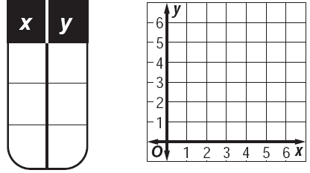

12. y = x + 1 13. x + y = 2

-1

-2

1

2

3

1

**Part IV: To Be or Not to Be … A Function**

**Do the following relationships represent functions? Explain your answer.**

14. 15. {(0, 6), (1, -3), (-2, 2), (1, -5)}

|  |  |
| --- | --- |
| ***x*** | ***y*** |
| 2 | 2 |
| 3 | 3 |
| 4 | 6 |
| 5 | 5 |

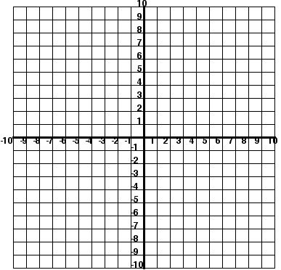 16. 17.

-1 -2 0 4

1 -4

5 7

9 -8

**# 18- 19 Given the following linear function, complete the table of values and graph on the coordinate plane provided. Then, identify the domain and range.**

**18. Function Rule: Table: Graph:**

|  |  |
| --- | --- |
| **Input x** | **Output**  **y** |
|  |  |
|  |  |
|  |  |
|  |  |
|  |  |



**y = x - 2**

Domain: __________

Range: ___________

**19. Function Rule: Table: Graph:**

|  |  |
| --- | --- |
| **Input x** | **Output**  **y** |
| **-8** |  |
| **-4** |  |
| **0** |  |
| **4** |  |
| **8** |  |



**y = x + 3**

**4**

Domain: __________

Range: ___________