SOL 8.14

**Name ___________________________________________** Course 3 Quiz

I. Match each table and rule with the graph that represents the same relationship.

Graph Table Rule



|  |  |
| --- | --- |
| x | y |
| -2 | 3 |
| 0 | 2 |
| 2 | 1 |
| 4 | 0 |

A. E. y= x + 2

1) _____ _____

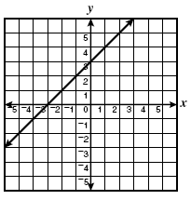

|  |  |
| --- | --- |
| x | y |
| -4 | -2 |
| -3 | -1 |
| -1 | 1 |
| 2 | 4 |

B. F. y = -x + 3

2) _____ _____

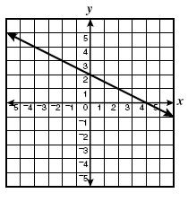

|  |  |
| --- | --- |
| x | y |
| -1 | 4 |
| 1 | 2 |
| 3 | 0 |
| 4 | -1 |

C. G. y = x + 3

3) _____ _____

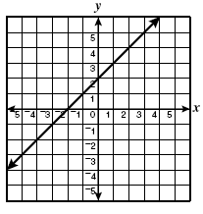

|  |  |
| --- | --- |
| x | y |
| -3 | 0 |
| -2 | 1 |
| -1 | 2 |
| 1 | 4 |

D. H. y = -½x + 2

4) _____ _____