Using Algebra Tiles to Model Solving Multi-Step Equations Notes

- 2x + 2 = 8 2) –x – 3 = 2

Model Solution Algebraic Solution Model Solution Algebraic Solution
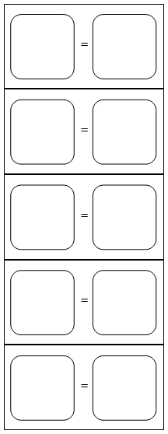
- 2(x + 2) = -4 4) –(2x – 1) = 5

Model Solution Algebraic Solution Model Solution Algebraic Solution

Using Algebra Tiles to Model Solving Multi-Step Equations Practice Name _______________________________

- 2x -5 = 2 2) 2(x – 1) = -6

Model Solution Algebraic Solution Model Solution Algebraic Solution
- -2(x -1) = -4 4) 2(x + 2) + 3 = 5

Model Solution Algebraic Solution Model Solution Algebraic Solution

