Warm-Up

In many countries, as well as the U.S., different types of coins are used to distinguish between the values each of them represents.

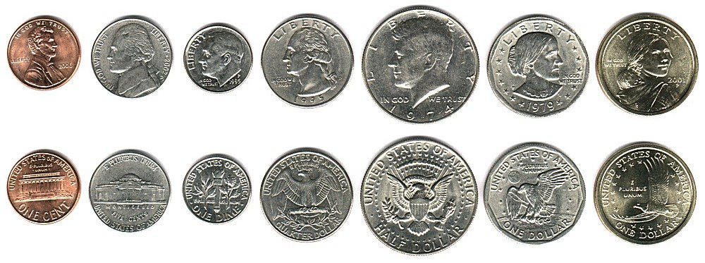

What are some characteristics of the coins that distinguish them from one another?

