Course 3: Ordered Pairs and Relations Name : _____________
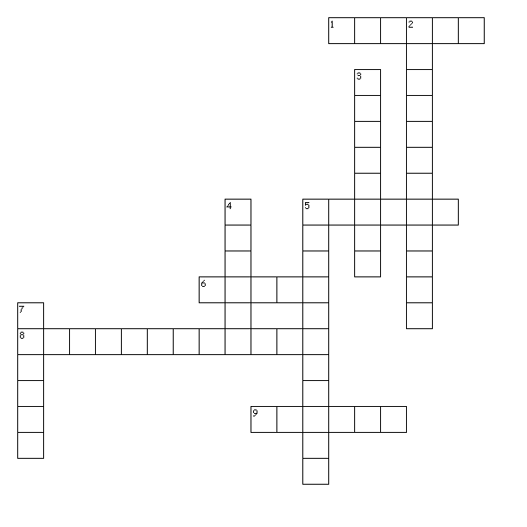
Across
1. the vertical number line
5. the point where the horizontal and vertical axes meet
6. the set of y-coordinates of a relation
8. the second number of an ordered pair
9. the horizontal number line

Down
2. the first number of an ordered pair
3. a set of ordered pairs
4. the set of x-coordinates of a relation
5. a pair of numbers used to locate a point
7. the system formed by the intersection of two number lines is called the coordinate ______

