Name ____________________ Date ____________ Block ________

Functions and Relations

1) What is a relation? __________________________________

2) What is a function? __________________________________

Use the graph below to answer questions 3 - 7
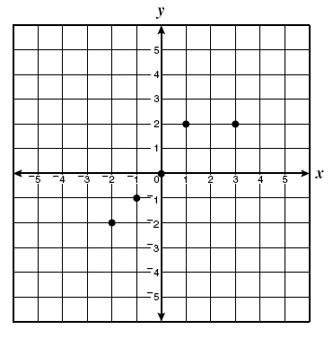

3) List the ordered pairs shown on the graph. _______________

4) Is it a relation? ______ How do you know? _______________

5) Is it a function? _____ How do you know? ______________

6) What is the domain?_________________________________

7) What is the range? __________________________________

8) True or False?

______ a) All functions are relations. Explain: ___________________

______ b) All relations are functions. Explain: __________________

