Relations and Functions Notes

**Vocabulary**

1. **Relation**
   1. Relation - a set of _______________ ____________________
   2. Example: ______________________________ is a relation because it is a set of ________________ _________________.
2. **Function**
3. Function - a _________________ in which each element of the _____________ (domain) is paired with **exactly** _______________ element in the ___________ (range) according to a specified rule.
4. Each _____________ has only 1 ______________.
5. Example: ____________________________________ is a function because each ______________value is paired with only 1 _____________ value.
   1. A function can be represented in several ways including:
   2. b.

c. d.

1. **Domain**
   1. Domain - the set of _______________ values for a function. (______________)
   2. Example – Given the function {(1, *5*), (2, *-3*), (3, *0*), (4, *2*)}

The domain is

1. **Range**
   1. Range - the set of _______________ values for a function. (____________)
   2. Example – Given the function {(1, *5*), (2, *-3*), (3, *0*), (4, *2*)}

The range is

1. **Linear Equation**
   1. Linear Equation - an equation for which the graph is a ____________ __________.
   2. 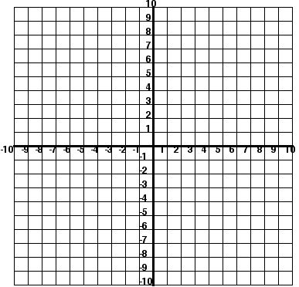Example:
2. Function Table
   1. Function Table - a table used to organize the input numbers, output numbers, and the function rule.
   2. Example: Given y = 2x + 3, create a function table.

|  |  |  |
| --- | --- | --- |
| x | y = 2x + 3 | Y or f(x) |
|  |  |  |
|  |  |  |
|  |  |  |
|  |  |  |

1. Independent Variable
   1. Independent Variable: The independent variable is the ____________ (___) value.
   2. It is the value that you may ______________.
   3. Note: If ______________is an option, it will always be the independent variable.
   4. Examples: ______________________________________________
2. Dependent Variable
   1. Dependent Variable: The dependent variable ______________ on the independent variable.
   2. It is the ____________ (________) value.