Name: Block:

1. Classify the following numbers as rational or irrational. Give a reason for your decision.
2. 7329

1. 
2. 0.95832758941…
3. 0.52875
4. Give an example of a number that would satisfy these rules.
5. a number that is: real, rational, an integer, whole and natural
6. a number that is: real and irrational
7. a number that is whole but is NOT natural
8. What is the smallest subset the following numbers belong?
9. 46
10. -8,546,999
11. -22.8

1. Place the following numbers in the Venn Diagram below. Note that some numbers may not be used!

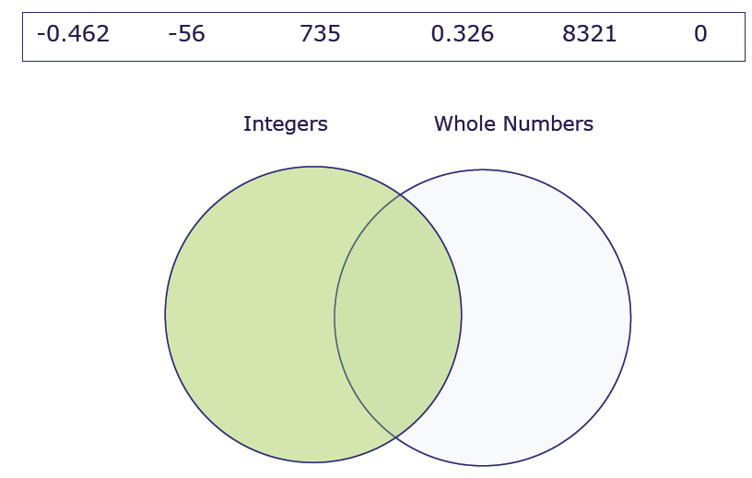

1. Circle all of the statements that are true.
2. Some integers are irrational numbers.
3. Every terminating decimal is an integer.
4. All integers are rational numbers.
5. All numbers are real numbers.
6. Every natural number is a whole number.
7. Every integer is a whole number.
8. Integers are always positive.