Name: ________________________________ Date: ________________

SOL 8.6 Notes – Adjacent Angles

Adjacent Angles:
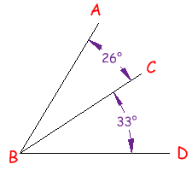
Two angles are _____________________ if they have a common side, a common vertex (corner point) and do not overlap.

Angle ABC is adjacent to angle CBD because:
- they have a common side (line CB)
- they have a common vertex (point B)

What Is and Is NOT an Adjacent Angle:
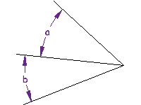 |  | 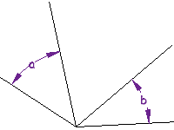 |  | 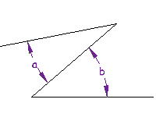
These ARE Adjacent Angles  They share a vertex and a side |  | NOT Adjacent Angles  they only share a vertex, not a side |  | NOT Adjacent Angles  they only share a side, not a vertex

Don't Overlap! PRACTICE:
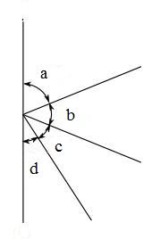
The angles must not overlap. Which of the following pairs of angles are NOT adjacent?

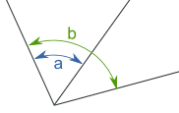
NOT Adjacent Angles
angles a and b overlap

Supplementary Angles:
Two Angles are _________________________________ if they add up to ____________ degrees.

These two angles (140° and 40°) are Supplementary Angles, because they add up to 180°.  Notice that together they make a straight angle, or straight line which is 180 degrees. | 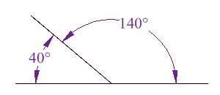
But the angles don't have to be together.  These two are supplementary because 60° + 120° = 180° | 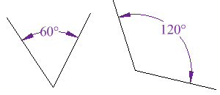

FUN TRICK TO REMEMBER:
“S” for Supplementary…. “S” makes 180!

S

PRACTICE PROBLEMS:
Two angles are supplementary and one of them is 31°
What is the size of the other angle?

Two angles are supplementary and one of them is 127°
What is the size of the other angle?

Complementary Angles:
Two Angles are ____________________________ if they add up to ______ degrees (Right Angle).
These two angles (40° and 50°) are Complementary Angles, because they add up to 90°.  Notice that together they make a right angle. | 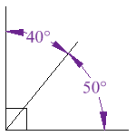
But the angles don't have to be together.  These two are complementary because 27° + 63° = 90° | 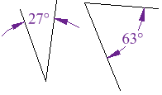

FUN TRICK TO REMEMBER:
“C” for Complementary…. “C” makes 90!
C

PRACTICE:
If two angles are complementary and one of them is 77°, what is the size of the other angle?

If two angles are complementary and one of them is 34°, what is the size of the other angle?

Name: __________________________________ Date: ________________

NOTES – SOL 8.6 – Vertical Angles

________________________________________ are the angles opposite each other when two lines cross.
"Vertical" in this case means they share the same Vertex (or corner point), not the usual meaning of up-down.
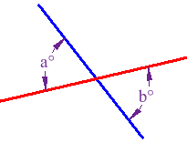
In this example, a° and b° are vertical angles.
Vertical angles are ALWAYS __________________________.

a° = b°

EXAMPLE: Find angles a°, b° and c° below:
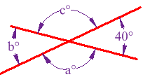
Because b° is opposite 40°, it must also be __________.
A full circle is ______°, so that leaves 360°- 2×40° = 280°
Angles a° and c° are also vertical angles, so must be equal, which means they are 140° each.
Answer: a = 140°, b = 40° and c = 140°.

PRACTICE PROBLEM: What is the measure of angles a°, b° and c° below?

