Name ______________________________ Date _____________________

**Complementary and Supplementary Angle Worksheet**

1. If two angles add up to 180o they are ________________________________ angles.

2. If two angles add up to 90°, they are _________________________________ angles.

One angle of a pair of complementary angles is given.

What is the measurement of the other angle?

3. 45° ________ 4. 82° ________ 5. 23° _________

One angle of a pair of supplementary angles is given.

What is the measurement of the other angle?

6. 173° ________ 7. 75° ________ 8. 92° _________

9. Name two pairs of supplementary angles in the figure below.

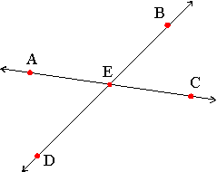

Angle - ______________________ Angle - __________________________

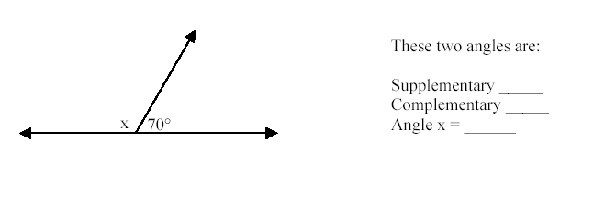

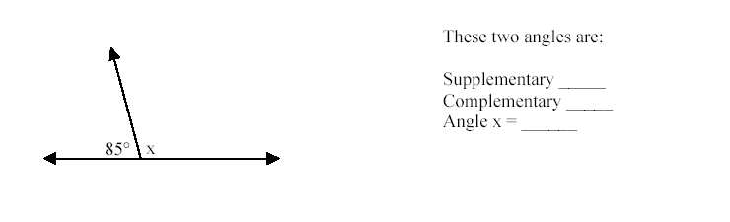11.

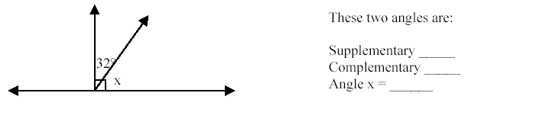12.