E# Volume & Surface Area
8.7 The student will investigate and solve practical problems involving volume and surface area of rectangular solids (prisms), cylinder, cones, and pyramids.

Name___________________________ Date__________ Block________
1.Surface Area | 10ft  6ft | Volume
2.Surface Area | 7ft  2ft  3ft | Volume
3.Surface Area | 6ft  6ft  6ft | Volume
4.Surface Area | 9cm 13cm  12 cm | Volume
5.Surface Area | 25ft  22ft  18ft | Volume
6. Surface Area | 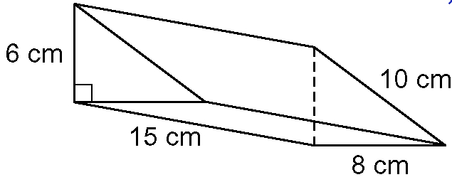 | Volume

