Volume and Surface Area of Nets

1. Rectangular Prism

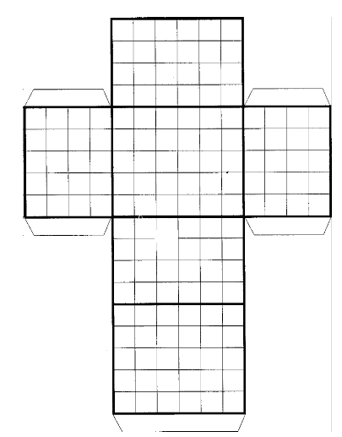Surface Area: Area of top/bottom + Area of front/back + Area of left/right



SA = _______________ + _______________ + _______________

SA = __________ + __________ + __________

SA = __________

SA FORMULA = ­­­­­­­­­­­­­­___________________________

Volume: Length x Width x Height

V= __________ x __________ x __________

V = ______________

VOL FORMULA = ____________

2. Triangular Prism

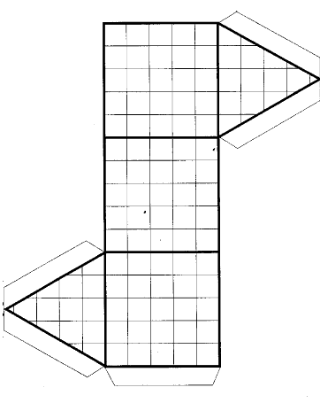Surface Area: Area Rect. 1 + Area Rect. 2 + Area Rect. 3 + 2(Area Bases)

SA = __________ + __________ + __________ + __________

SA = __________ + __________ + __________+ __________

SA = __________

SA FORMULA = ______________________________

Volume: Area of Base x Height

V = _________ x _________

V = _____________

VOL FORMULA = _______________

3. Cylinder

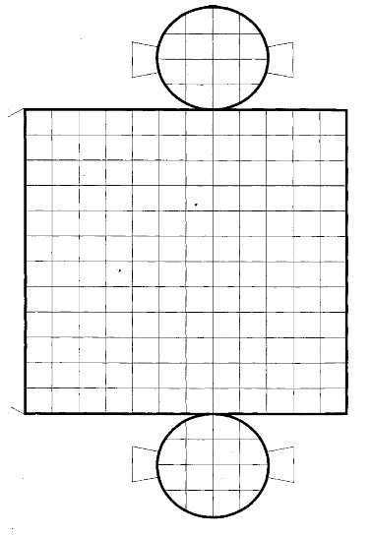Surface Area: Area of bases + Lateral side area (rectangle)

SA = ______________ + __________________

SA = ____________ + _______________

SA = ____________________

SA FORMULA = _________________________

Volume: Area of a base x Height

V = ______________ x ______________

V = ________________

VOL FORMULA = ______________________

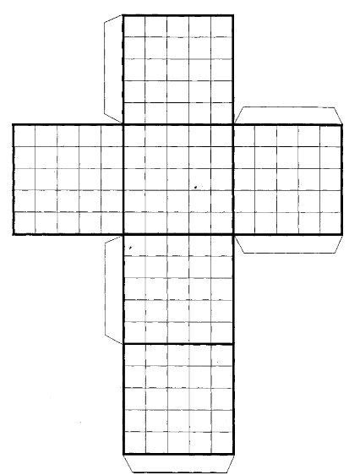4. Cube

Surface Area: Area of top/bottom + Area of front/back + Area of left/right



SA = _______________ + _______________ + _______________

SA = __________ + __________ + __________

SA = __________

SA FORMULA = ­­­­­­­­­­­­­­___________________________

Volume: Length x Width x Height

V= __________ x __________ x __________

V = ______________

VOL FORMULA = ____________

5. Pyramid

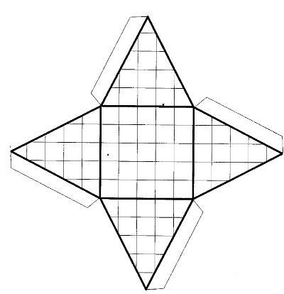Surface Area: Area of Base + Area of triangles

SA = ______________ + __________________

SA = ____________ + ______________

SA = ____________________

SA FORMULA = _________________________

Volume: Area of the Base x Height

V = ______________ x ______________

V = ________________

VOL FORMULA = ______________________

6. Cone

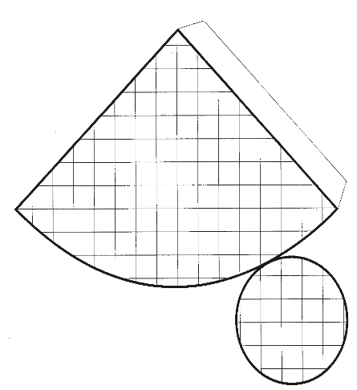

Surface Area: Area of Base + Pi (radius)(slant height)

SA = ______________ + __________________

= ____________________

SA FORMULA = _________________________

Volume: Area of the Base x Height

= ______________ x ______________

= ________________

VOL FORMULA = ______________________