Transformations Practice

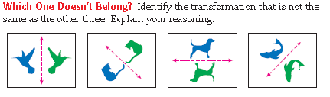

1.



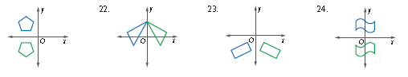2.

d.

c.

b.

a.



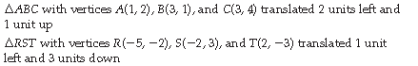

3.

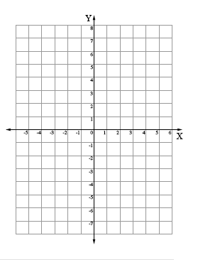4.

4.

3.



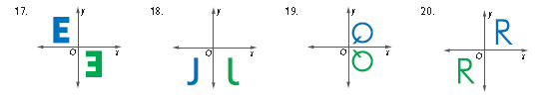

6.

5.

8.

7.

9. Look at the figure on the coordinate plane below. If it is rotated 180 degrees about the origin, what quadrant will it be in?

10. Look at the figure on the coordinate plane below. If it is rotated 270 degrees *counterclockwise* about the origin, what quadrant will it be in?

