Transformations
SOL 7.8

Vocabulary
Horizontal Axis:

Vertical Axis:

Origin:
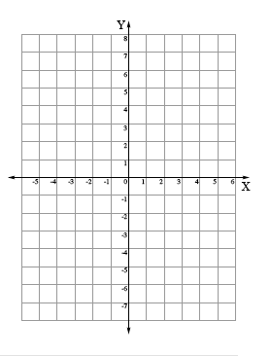
Reflect

Treat each axis as a ______________________. Your

new figure should be the _______________________

of the original one.

Rotate

To figure out which quadrant your figure will be in,
start where your figure is located. Then move to the
next quadrant ___________________________.

1 quadrant= _________________
2 quadrants =________________
3 quadrants= ________________
4 quadrants= ________________

Translate
(x-axis, y-axis)
(right or left, up or down)
(+ or -, + or-)

- Right 4, down 1
- Left 2, up 3
- (1, -5)
- (0, 3)

Dilate

- Dilate 2.

- Dilate ¼.

