3-D Figures

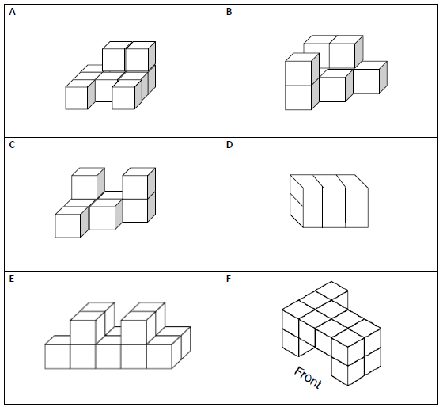
On your own paper: Draw the Top, Front, and Side Views of Figures A – F.

