E#
Name: _______________________________
Date: ______________
Block: ___________
SOL 8.9: 3-D Figures

Draw the Top, Front, and Side Views of Figures A – F.
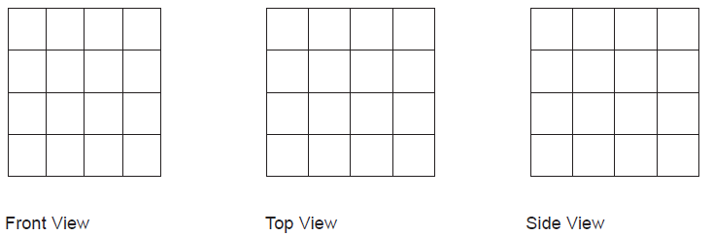
Figure A

Figure B

Figure C

Figure D

Figure E

Figure F

