3-D Figure Patterns

Make Figures A – D using the linking cubes using the Top, Side, and Front Views below.

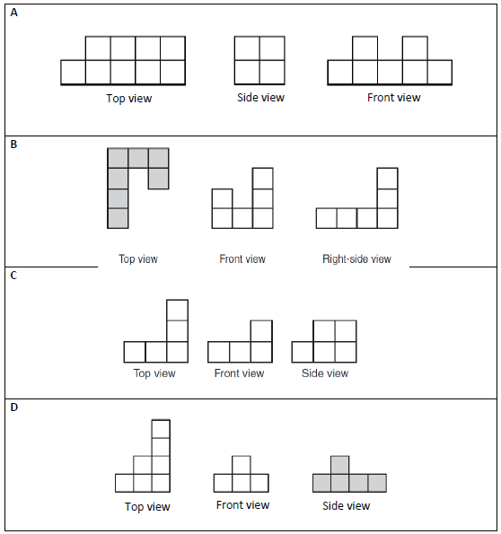
Check your figure with your partners figure to make sure you both are correct.

