Name_______________________________________________ Date______________________
Simplify each expression. State what to do to each coefficient and each exponent.
Coefficient Rule: _________________
________________________________
Exponent Rule: __________________
________________________________
1) $\frac{x^{5}}{x^{4}}$ 2) $\frac{{5a}^{10}b}{a^{4}}$
Coefficient Rule: _________________
________________________________
Exponent Rule: __________________
________________________________

3) $\frac{{27x}^{3}z^{5}}{{3x}^{3}z^{8}}$ 4) $\frac{9x^{2}}{45x^{-3}y}$
Coefficient Rule: _________________
________________________________
Exponent Rule: __________________
________________________________
Coefficient Rule: _________________
________________________________
Exponent Rule: __________________
________________________________

Simplify each expression.

7) $\frac{x^{8}y^{10}}{x^{2}y^{4}}$ 8) $\frac{a^{-5}}{a^{0}}$ 9) ${\left(\frac{x^{4}y^{5}}{xy^{2}}\right)}^{2}$

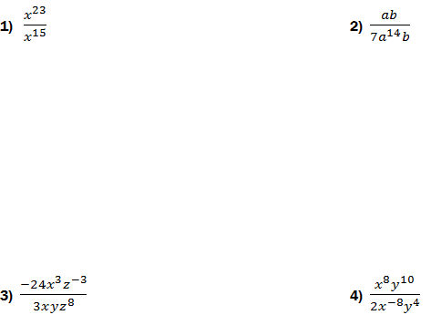

***REVIEW adding and subtracting polynomials***
Simplify each expression using addition or subtraction.

Anything raised to the zero power equals what number? __________
What do you do with a negative exponent to make it positive?______________
When multiplying variables you _____________ the exponents.
When dividing variables you _____________the exponents.
When a variable with an exponent is raised to a power, you __________________ the exponent and the power.

