Name_________________________________________ Date___________________________
ADDING POLYNOMIALS

When adding polynomials, __________________________________________________________________

1) $\left(9y-7x+15a\right)±3y+8x-8a)$ = _______________________________

2) $\left(3a^{2}+3ab-b^{2}\right)+\left(4ab+6b^{2}\right)$ = _______________________________

Write what each tile represents and simplify the expression.
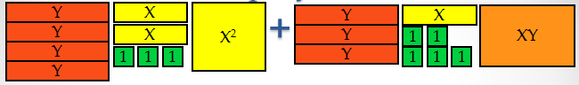

SUBTRACTING POLYNOMIALS

Subtract polynomials by_____________________________________________________________________
4) $\left(9y-7x+15a\right)-(-3y+8x-8a)$= _______________________________

5) $\left(5a-3b\right)-(2a+6b)$= _______________________________

6) $\left(5a-3b\right)+(2a+6b)$= _______________________________

