Name: ___________________________________________ Date: __________________

A Linear Equation is an equation that forms a _________________________________________________.

Linear Equations can be written in many forms. One of the most useful forms of linear equations is :

______________________________________________

It looks like : ______________________________________________

Two very important characteristics of linear relationships can be seen in this equation:

__________________________________ and ______________________________________
y = m x +b

SLOPE
Definition: ________________________________________________________________________________

_________________________________________________________________________________________

Slope can be…

___________________ __________________ _________________ ________________
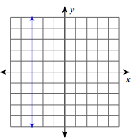
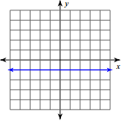
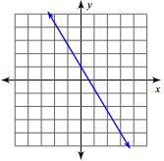
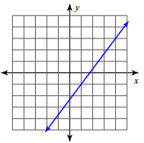
There are three ways that are often used for finding slope depending on the representation that you are given.

Slope = m = __________________ = ____________________ = __________________

Finding Slope from a TABLE: (the SAME as finding the rate of change) Use slope = _________________

X | Y
-4 | 10
0 | 5
4 | 0
8 | -5
X | Y
10 | 1
8 | 4
6 | 7
4 | 10
X | Y
2 | 8
3 | 10
4 | 12
5 | 14

Slope: _______ Slope: _______ Slope: _______

Finding Slope from a graph Use slope = __________________

1) __________________________________________________________________________________

2) __________________________________________________________________________________

Examples:
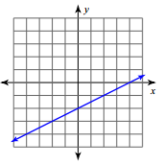
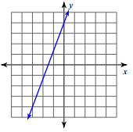
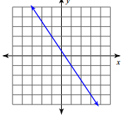

Slope: ____________ Slope: ___________ Slope: ___________

Finding Slope from 2 points: Use slope = _________________ given $\left(x_{1}, y_{1}\right)\left(x_{2}, y_{2}\right)$

Examples:

1) (2,3) and (8,10) 2) (-3,5) and (2,0) 3) (-1,-2) and (-1, 4)

Slope = __________ Slope = _____________ Slope = ___________

Finding slope from an equation in slope-intercept form:

Remember that the m is the ___________________________ which is the coefficient in front of x when the equation is solved for y.

Examples:

1) y = -2x - 5 2) x – 2y = 6 3) y = x +7 4) y = 4

Slope: _______ Slope: ________ Slope: _________ Slope: _________

