Simplify using the rules for dividing polynomials
- $\frac{x^{14}y^{-3}}{x^{6}y^{9}z^{8}}$ 2. $\frac{{100m}^{33}n^{3}}{25{xm}^{11}n^{2}}$

Simplify using foil or the box method for multiplying polynomials.
$3. (5x-1)(5x+1)$ 4. $(3m^{2}+2r)(3m+2r)$

Solve and graph the solution of each inequality.
5. $\frac{-6+x}{2}≤-1$

6. $3x≥-9$

7. Give the slope and y intercept of each equation.

$y=5x-12$ $y=\frac{-3}{2}x$ $12x+6y=36$

8. Mary is going bowling.
- The cost per game is $3.50.
- She will rent a pair of bowling shoes for $1.50.
- She can spend up to $18 to bowl and rent a pair of shoes.
What is the maximum number of games Mary can bowl?
- 4 C. 6
- 5 D. 9

- Write an inequality that represents all the solutions of$9(4x-8)<4(6x+9)$?

10. Janet is hiking this year in Florida. The following table describes the trails she can hike. If she has already hiked on Citrus Hiking Trail and the Big Oak Trail and plans to hike no more than 125 miles this year and now plans to hike d day trips of 5 miles each. Which inequality will represent this situation?

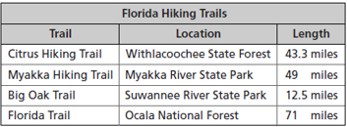

$A. 5d-125≤55.8$ $C. 55.8-5d=125$
$B. 5d+55.8≤125$ $D. 5(d-55.8)<125$

