Directions :
Guiding Questions:
- What is the question asking?
- What do you know
- What is your plan?
- Does the answer make sense and did you answer the question?
Use your guiding questions to answer the questions.

Underline the question. Place all information necessary in the work box from the question. Create a plan and show your work to solving the problem. Go back and make sure you answered the question and it makes sense.
Solve the problems in the space provided on the right side of the paper. In the little box on the upper corner, mark a +, -, or ? based on your understanding of the question.
What are the three steps to solve this problem?  Then solve the problem.  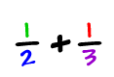 | 1.  2.  3.  Answer:
What are the three steps to solve this problem?  Then solve the problem.  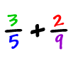 | 1.  2.  3.  Answer:
What are the three steps to solve this problem?  Then solve the problem.  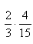  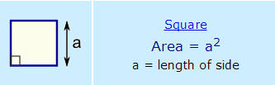  Area:  Perimeter:  Find the area and perimeter of a horse stall that has a side length of 12 feet. | 1.  2.  3.  Answer:
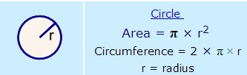  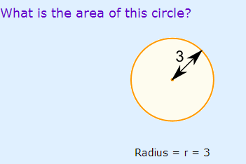  What is the area and perimeter of this circle. | Area:  Perimeter:

Greg and Peter bought a large pizza to share. Greg ate 5/8 of the pizza. What is the fraction of pizza that is left for Peter?

What are the five Ps and what do they mean? | 1.  2.  3.  4.  5.

