Directions :
Use your guiding questions to answer the questions.
Underline the question.
Place all information necessary in the work box from the question.
Create a plan and show your work to solving the problem.
Go back and make sure you answered the question and it makes sense.

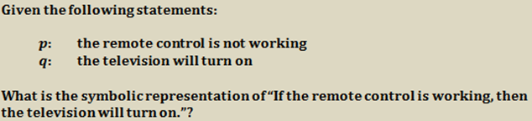
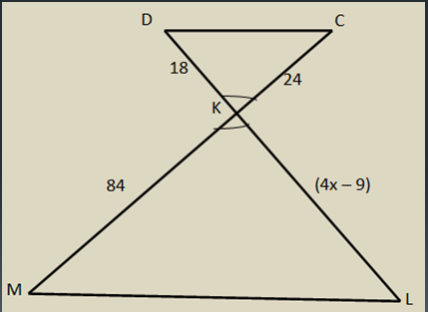
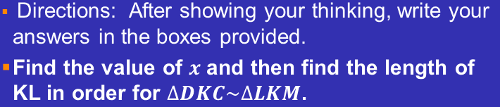
In triangle $PQR$, $m P$ = 60°, $m Q$ = 77°. Order the sides of the triangle from longest to shortest. Write the sides in order in the box provided to the right.

Write the equation of the line parallel to $y = -3x-7$ through the point$(4, 1)$. Write the slope and $y$-intercept in the boxes provided. All three parts and the equation must  be completed.  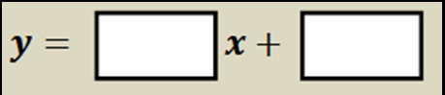 | Slope of original line:  Slope of new line:  y-interecept of new line:
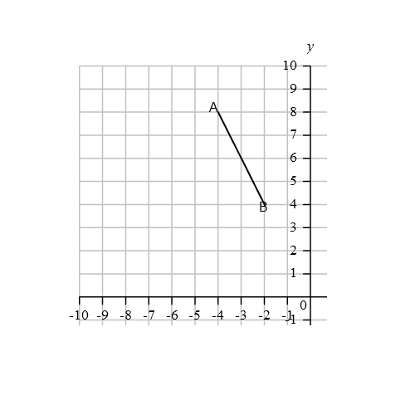  Construct the Perpendicular bisector of segment AB. All four sections must be answered and graph provided. | Slope of line AB:  Slope of new line:  Midpoint of AB:  Point of intersection:

