Directions :
Use your guiding questions to answer the questions.
Underline the question.
Place all information necessary in the work box from the question.
Create a plan and show your work to solving the problem.
Go back and make sure you answered the question and it makes sense.

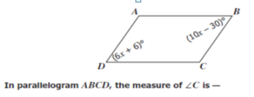
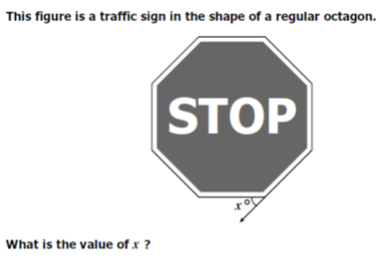
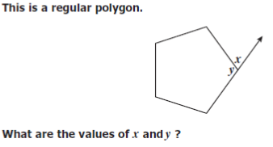
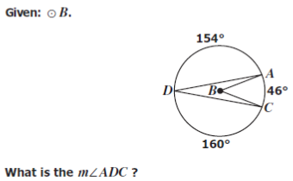

Give the exact area in terms of pi for the shaded sector.

