Directions :
Use your guiding questions to answer the questions.
Underline the question.
Place all information necessary in the work box from the question.
Create a plan and show your work to solving the problem.
Go back and make sure you answered the question and it makes sense.

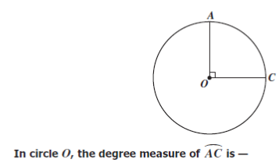
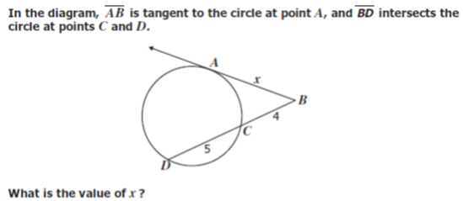
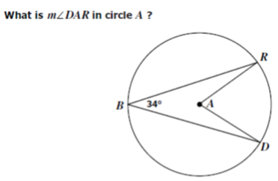
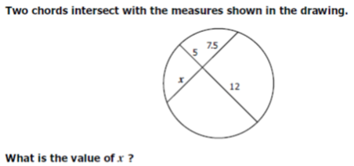

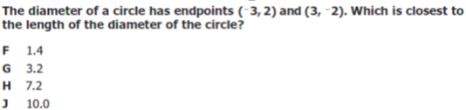

If a cylindrical barrel measures 22 inches in diameter, how many inches will it roll in 8 revolutions along a smooth surface?
A 121πin.
B 168πin.
C 176πin.
D 228πin.

