Directions :
Use your guiding questions to answer the questions.
Underline the question.
Place all information necessary in the work box from the question.
Create a plan and show your work to solving the problem.
Go back and make sure you answered the question and it makes sense.

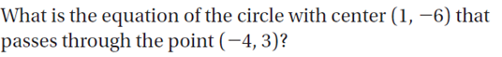
What is the center and radius of the given circle? 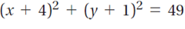

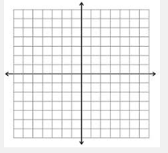
Write the equation of a circle with center (1, 0) and radius 4 and sketch the graph.

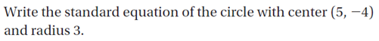

What is the measure of the angle formed by two adjacent wheel spokes?

The figure shows the path of a windshield wiper. What is the approximate area of glass that will be cleared?
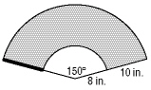
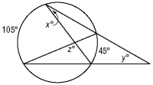
What are the values of X, Y and Z?

