Directions :
Use your guiding questions to answer the questions.
Underline the question.
Place all information necessary in the work box from the question.
Create a plan and show your work to solving the problem.
Go back and make sure you answered the question and it makes sense.
Solve the problems in the space provided on the right side of the paper. In the little box on the upper corner, mark a +, -, or ? based on your understanding of the question. Place a + mark if you know the question and are confident of your answer; place a – mark if you are unsure of the question but have an idea of where to start; place a ? mark if you do not know where to begin a plan.
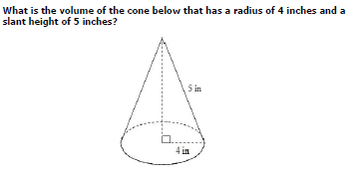
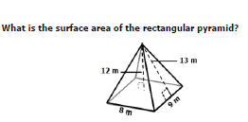
A tepee in the shape of a right cone has a slant height of 18.5 feet and a
diameter of 20 feet. Approximately how much canvas would be needed
to cover the tepee?
How much leather will be needed to cover a ball with a diameter of 6 inches?

