Directions:
Use your guiding questions to answer the questions.
Underline the question. Place all information necessary in the work box from the question. Create a plan and show your work to solving the problem. Go back and make sure you answered the question and it makes sense.
- Give the converse in symbolic form of the following
Conditional statement:

~P Q
- Write the inverse (using words) for the following
Conditional statement:

If you are a math teacher, then you love pi.
- Write the conclusion to the following statements and which law you used to draw your conclusion (Detachment or Syllogism)

If you are my friend, then you won’t let me divide by 0.
Mrs. Joyner is my friend.
Underline the hypothesis and circle the conclusion for each conditional. Write the converse, inverse, and contrapositive. Next to each, write the correct symbolic notation.  lf you like geometry, then you are cool. | - Converse:______________________________________  ___________________________Symbolic:___________  - Inverse:_________________________________________  ________________________Symbolic:_______________  - Contrapositive:___________________________________  _______________________Symbolic:_______________
- If m∠ABC = 3x +12 and
m∠CBD = x −8 , then find x.

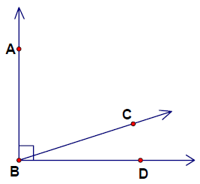
- How do you write the inverse of the conditional statement below?

“If m∠1 = 60°, then ∠1 is acute.”

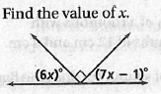
- Define the following words:

Complimentary Angles:

Supplementary Angles:

