8-10 Pythagorean Theorem
NAME:______________ DATE:________________
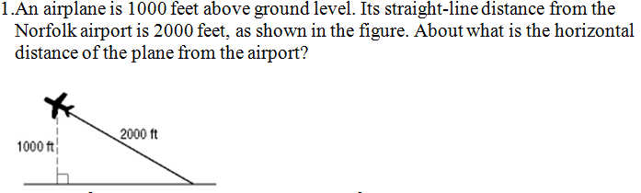
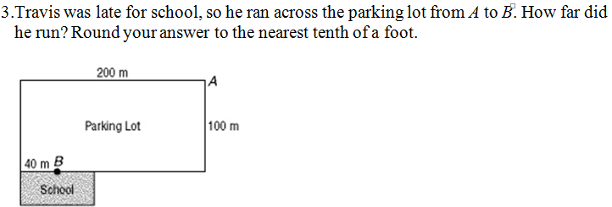
4. Solve for X.
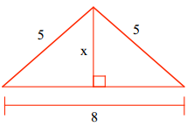

5. George owns a 500 acre farm thirty miles from town. He keeps pigs in a pen that is 16 feet long and 12 feet wide. He wants to split the pen diagonally to create two new pens. How long will the fence be that he needs to build to split the pen?
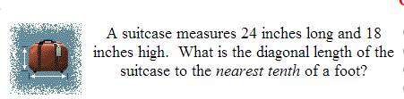
6.
7. A right triangle has a hypotenuse of 5cm and a leg of 3cm how long is the other leg?

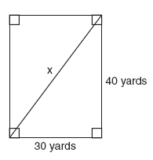
8. 9.
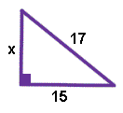

10. Which side in a right triangle must be the largest?
11. What is the degree measure of the angle across from the hypotenuse in a right triangle?
12. What is the name of a triangle with two congruent sides?
13. What is the name of a triangle with three congruent sides?
14. What is the name of a triangle with no congruent sides?
15. Pick which situation you would use the Pythagorean Theorem to solve the problem:
a. A ladder is leaning against a building. You know the height of the ladder to be thirty-five feet. How many stairs are in the building?
b. A flag pole has a guide wire that is 25 feet long and anchored 13 feet from the base of the flag pole. How tall is the flag pole?
c. You want to paint your bedroom that is fourteen feet long and twelve feet wide. How much paint do you need?
16.
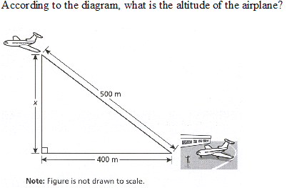
17. Decide if each set of numbers can create a right triangle:
a. 3, 4, 5 g. 24, 7, 25
b. 9, 12, 15 h. 8, 15, 16
c. 12, 13, 19 i. 8, 15, 17
d. 41, 9, 40 j. 1, 2, 2
e. 65, 63, 16 k. 200, 241, 49
f. 19, 180, 195

