Home work Week 2 Algebra part 2
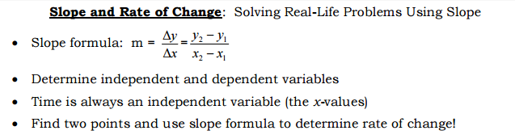
- Find the slope of the lines formed by the following sets of 2 points. Express your answers as fractions in simplest form (that is, don’t convert fractions to decimals).  - (-1, 5) and (-2, 6)  - b) (4, 8) and (-2, 12)  - c) (-5, -3) and (-2, -3) | 6. Does the table below represent direct, inverse variation or neither. If it represents a direct or inverse variation, find the constant of variation, and write an equation for the function.  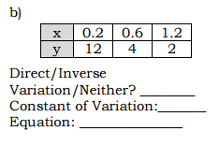
- A scuba diver is 30 feet below the surface of the water 10 seconds after he entered the water and 100 feet below the surface after 40 seconds. What is the scuba divers rate of change? | 7. Each ordered pair is from an inverse variation.  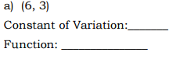
- A rocket is 1 mile above the earth in 30 seconds and 5 miles above the earth in 2.5 minutes. What is the rockets rate of change in miles per second?  (Hint: Convert minutes to seconds first) | 8. Solve for n.  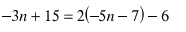
- Does the table represent direct variation?  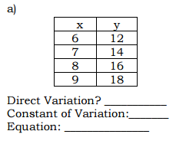 | 9. Analyze each relation shown below. Is the relation a function? Explain.  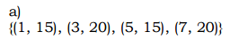  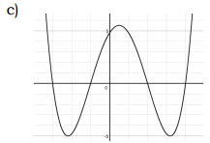
- Julio’s wages vary directly as the number of hours that he works. If his wages for 5 hours are $29.75, how much will they be for 30 hours? | 10. 