Home work Week 3 Algebra part 2
- Factor
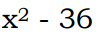

- Factor (Hint-factor GCF first)
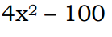

- Solve the equation by factoring
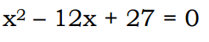

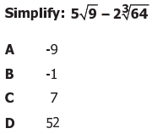

5.

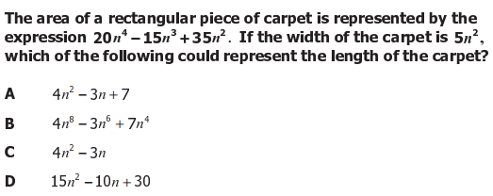
6.
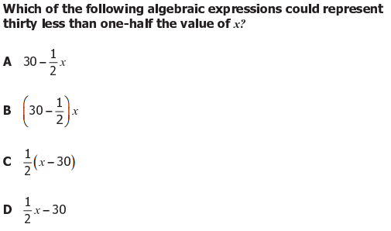
7.
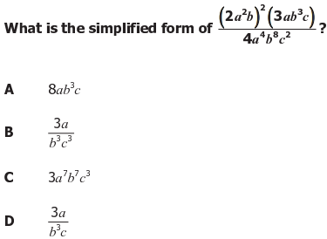
8.
9.
10.
