Home work Week 4 Algebra part 2
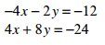

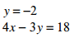

- Create two equations. Let one variable be x and one be y. Use the variables to create one equation where they sum to 12 and one where they subtract to make 4.

Find the value of two numbers if their sum is 12 and their difference is 4

- Solve the equation by factoring. Make sure it is set equal to zero first by moving all terms to the same side.
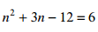

- Solve the inequality and graph the solution.

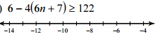

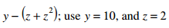
- Sketch the solution to the system of ineqaulities. Don’t forget shading.
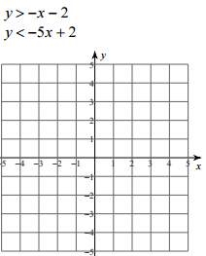
- Subtract the polynomials. Don’t forget to change the sign and second set.
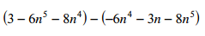
- Add the polynomials.
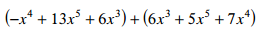
- Simplify
