

1.



**2. “If there is school tomorrow, then today is Sunday.”**

**What is the converse of the conditional statement shown above?**

**A** If there is no school tomorrow, then today is not Sunday.

**B** If today is Sunday, then there is school tomorrow.

**C** If today is Sunday, then there is no school tomorrow.

**D** If there is school tomorrow, then today is not Sunday.

**3. The two statements provided below are given:**

Mastery Target: 7/8 = 88%

**“If the rain amount exceeds ten inches, then the creeks will overflow.”**

**“If the creeks overflow, then the local streets will be flooded.”**

**Using the law of syllogism, what is the correct conclusion for the above argument?**

**A** The local streets will be flooded.

**B** The creeks will overflow.

**C** If the rain amount exceeds ten inches, then the local streets will be flooded.

**D** If the creek overflows, then the rain amount exceeds ten inches.

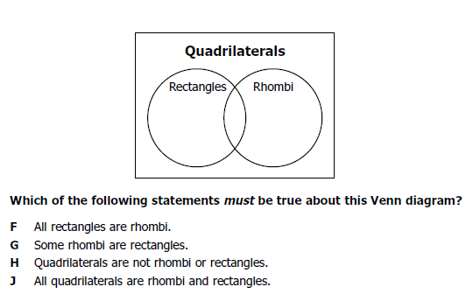

4.

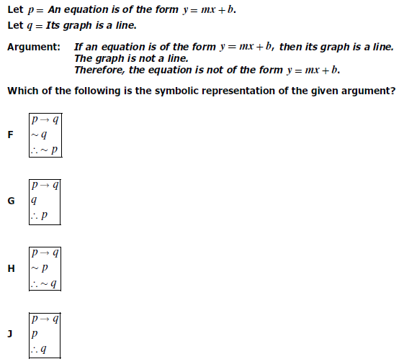

8.

5.

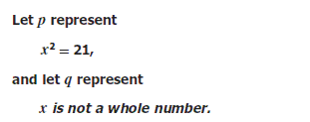

6.

What is the representation of the statement:

If , then .





7.

