Notes on Similar Figures:
SOL G.14
Definition of Similar Solids:
Two solids of the same type with ____________________ of corresponding linear measures (such as heights or radii) are called similar solids.

To compare the ratios of _______________________ side or other linear lengths, write the ratios as __________________ in ____________________________.

What are the variables for a rectangular prism on your formula sheet?
_________________________________________________________
Are these shapes similar? Let’s find out!

Compare the lengths as a fraction:_____________
Compare the widths as a fraction:_____________
Compare the heights as a fraction:____________
Are they all the same fraction?________________
Are the shapes similar?____________________
What are the variables in the cone formula on your formula sheet?
_______________________________________________________

Are these solids similar? Let’s Find out!
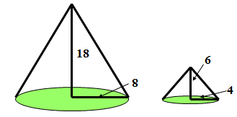
Compare the radii as a fraction:_________________
Compare the heights as a fraction:_______________
Are they the same fraction? ___________________
Are the shapes similar?________________________
Similar Solids and Ratios of Areas:
If two similar solids have a scale factor of _____________, then corresponding ______________have a ratio of _____________.

This applies to _____________________, ________________________, or ___________________________.

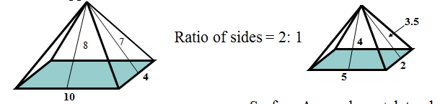

What is the ratio of the sides?___________________________
What is the surface area of figure 1?_______________
What is the surface area of figure 2?_______________
What is the ratio of the surface areas?__________________
What do you notice?________________________
Similar Solids and Ratios of Volumes
If two similar solids have a scale factor of ______________, then their _______________ have a ratio of _______________.

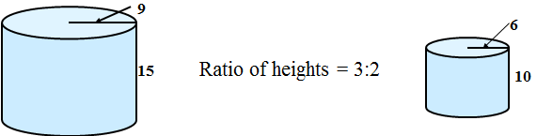
What is the ratio of the heights?___________________________
What is the ratio of the radii?
What is the Volume of figure 1?_______________
What is the Volume of figure 2?_______________
What is the ratio of the volumes?__________________
What do you notice?________________________

