Given the line created by points A (-5, -1) and B (-3, 0); find a point that creates a parallel line that goes through point C (3, 2 ).  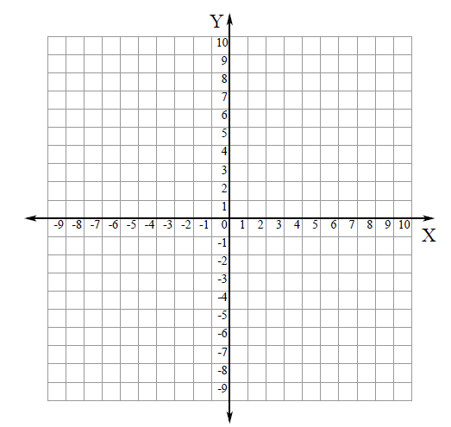 | Given the line created by points A (6, 2) and B (4, 4); find a point that creates a perpendicular line that goes through point C (2, 0).
Given the line created by points A (7, -3) and B (5, 0); find a point that creates a parallel line that goes through point C (6, 3). | Given the line created by points A (-6, -4) and B (-2, 2); find a point that creates a perpendicular line that goes through point C (3, 2).

Given the line created by points A (-5, 2) and B (-5, -3); find a point that creates a parallel line that goes through point C (2, -2). | Given the line created by points A (6, 4) and B (-2, 4); find a point that creates a perpendicular line that goes through point C (-5, -2).

