6. What is the value of the expression when n= -3

$-4\left|n-10\right|$

NAME: __________________BLOCK__________________ DATE_________________

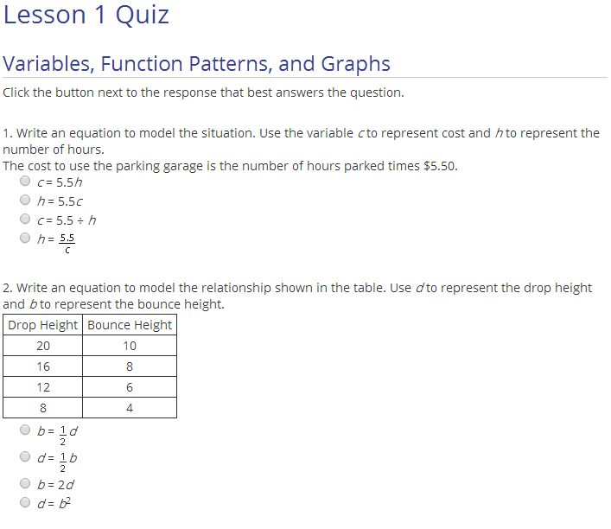

3. Write a verbal expression for

4. Write an algebraic expression for the sum of the cube of a number and 21.

5. Write an expression for four less than half a number, n.