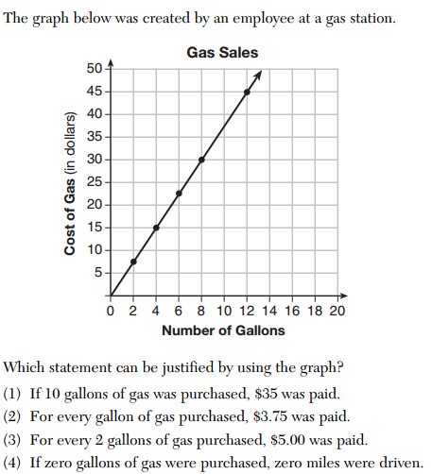
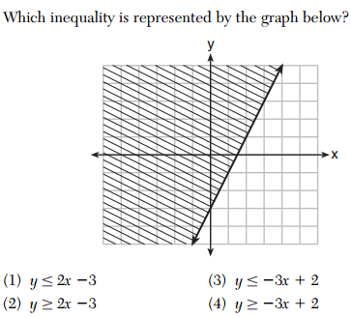
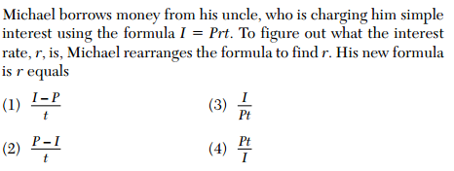
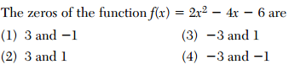
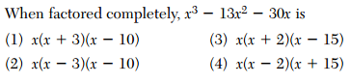
The Reel Good Cinema is conducting a mathematical study. In its theater, there are 200 seats. Adult tickets cost $12.50 and child tickets cost $6.25. The cinema sold $1500 worth of tickets. Write a system of equations to solve for the number of adult tickets (A) and the number of child tickets (C).  ____________+___________=200  ___________+____________=1500  SOLVE: | Number of child tickets:  Number of adult tickets:

