Nottoway County High School
Algebra I Syllabus

TEACHER: Jenna Finnegan Skype Name: Jenna.Finnegan1
EMAIL: Finnegan.Jenna@nottowayschools.org

Course Description:
Algebra 1 is intended to build a foundation for all higher math classes. This course will review algebraic expressions, integers, and mathematical properties that will lead into working with variables and linear equations. There will be an in-depth study of graphing, polynomials, quadratic equations, data analysis and systems of equations through direct class instruction, group work, homework, student projects and technology.

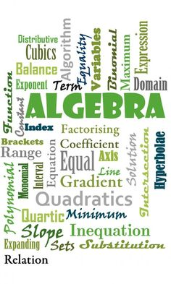
Course Requirements:
- Composition Notebook
- Three-ring binder
- Loose-leaf notebook paper (college ruled)
- Pencils – everything must be done in pencil
- Colored Pencils
- Graph Paper

Grading:
Bell ringers: 5 %
Problem of the Day: 20%
Homework: 20%
Quiz: 20%
Test: 35%

Mission Statement:
The mission of Nottoway High School is to provide a positive, secure environment, which fosters academic, cultural and social growth. We aspire to cultivate life-long learners who continually grow, adapt and contribute in a diverse global society.

Classroom Code of Conduct:
- At teacher’s signal stop talking
- Don’t speak out of turn
- Respect others
- Be ready with your work
- Participate positively in class

Failure to comply with any classroom code of conduct provision will result in the following consequences:

- Verbal Warning
- Student / Teacher Conference
- Parent or Guardian Phone Call
- Office Referral

Homework:
Homework will be assigned on Monday and will be due on Friday by the end of class unless otherwise stated.

Notebooks:
Students must keep a composition notebook up to date with notes and examples from class. This notebook will be checked and counted as a quiz grade during most test sessions or at the teacher’s request. This notebook must be brought to class every day. Students are also expected to keep a binder that organizes their completed homework assignments, worksheets, study guides, quizzes and tests.

Textbooks:
A classroom set of textbooks will be kept in the classroom for student use. If a student needs a textbook for home use then they will be issued a textbook for this course if requested and the textbook should be kept covered. It is the student’s responsibility to ensure that these textbooks are kept in good condition and are returned at the end of the semester. Reimbursement to the school system is expected should loss or damage to the textbook occur while in the care of the student.

Make-up Work:
It is the student’s responsibility to check for missed work and notes given the day of an absence.

I have read and fully understand the math class information for the 2016-2017 school year, and recognize that these policies may require modification by the teacher if deemed necessary.

Student Name (Printed): ____________________________________

Student Signature: ________________________________________

Parent Name (Printed): _____________________________________

Parent / Guardian Signature: ________________________________

Primary Contact Name: __________________________________

Home Phone: ____________________________________________

Cell Phone: ______________________________________________

Work Phone: _____________________________________________

Email: ____________________________________________________

Return this form to Ms. Finnegan by Friday August 19, 2016 for a homework grade.

