Taxes Test
**Using the tables below answer the following questions and round all answers to the nearest dollar.
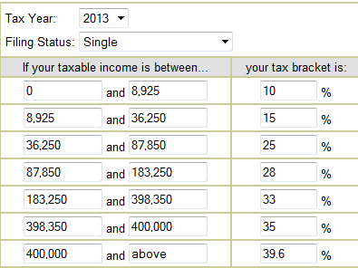
- Ms. Honey is a single lady who makes $45,000 as a teacher. She also works a summer job and earns $4,000. What is Mrs. Honey’s income tax bracket? ___________________ What is the average of all the brackets she falls under? ____________________ Approximately how much can Mrs. Honey expect to pay in income taxes for 2013?_________________

- Mr. and Mrs. Finnegan are married. Mr. Finnegan is a spy and makes $250,000 a year. Mrs. Finnegan is a professional horse back rider and makes $75,000 a year. They plan to file their taxes together. What income bracket will they fall into for their taxes?________ What is the average of all the brackets that they fall under?_______ Approximately how much can Mr. and Mrs. Finnegan expect to pay in income taxes for 2013?______________

- Jerry Trig works a part time job during college and earns $12,789 for the year. (He is single) What is Jerry Trig’s income tax bracket?_______ What is the average of all the brackets he falls under?______ Approximately how much can Jerry Trig expect to pay in income taxes for 2013?

- Joe Dirt is an engineer and makes $89,677 a year. His fiancée Jane Mudd is an astronaut and makes $68,512 a year. Use math to show if getting married and filing jointly would save them money or cost them money on their taxes.

Taxes paid by Joe single____________ + Taxes paid by Jane single______________=_____________

Taxes paid by Joe and Jane Married =_________________

Do they save money by getting married and filing jointly or do they lose money? How much?
