NAME: Slope Intercept Form: y=mx+b
DATE: Standard Form: Ax+By=C
BLOCK: Point-Slope Form: Y-Y₁=m(X-X₁)

1.When graphing you always 2. When graphing you use the _________
plot the ______________ to plot your second point.
first.
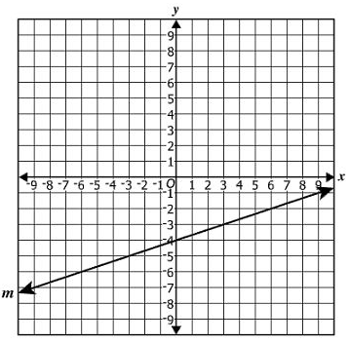
3. Which equation best represents line m?
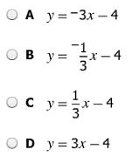

4. Which gives the slope of line l ?
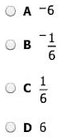
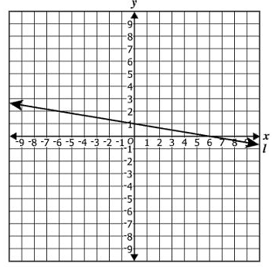

5. Which number is not an element in the domain of this relation?
{(-2, 3), (0, 4), (1, 1), (6, 0)}
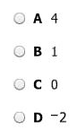

6. Fill out the table and then graph the points to create the line.
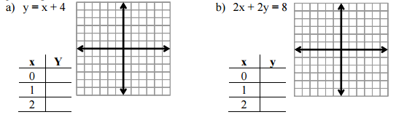

7. Graph using x and y intercepts.
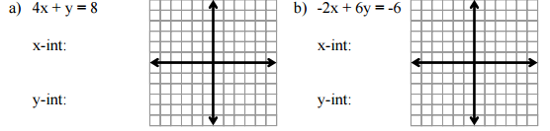

8. Graph using y-intercept and slope.
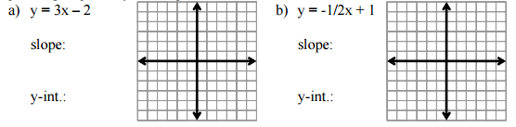

9. You have $20 and spend $2.50 every day on lunch.
a. Write an equation for the amount of money you have.
b. Define the variables: x=______________________ y=_________________________________.
c. x-intercept=__________________ y-intercept=____________________________.

d. slope of the line:_________
10.
a. Draw the graph for the equation above.
b. Does the graph increase or decrease? Why?

